Technical Story Card

Revision History
Version No. | Date | Prepared by / Modified by | Significant Changes
1 | 29 December 2021 | Liberal Dharmaji Zarkar (PL0921249),  Tallapally Kousalya (PL0921244),  Ravikiran Reddy Kandula (PL0921245),  Preethi N (PL0921248) | Final version

Table of Contents
1 Introduction 3
2 Scope of Change 3
3 List of modules 3
4 Design and Detailed technical updates 4
4.1 Process model 4
4.1.1 Use case Model 4
4.1.2 Sequence diagram 4
5 References 5

Introduction
Bill Payment Application is a concept, describing a set of technology-based solutions that aim for easy payment processing and improve business efficiency for customers and for the retailers linked in a bill transaction. The idea work by automating transactions and tracking invoice approval, from initiation to completion.

Under this paradigm, retailers can easily generate bills or invoices for the customers for easy bill payment transactions. And by providing short-term credit that optimizes working capital and provides liquidity to both parties. It also offers distinct advantages to all participants. While customers gain a quicker view of the bill generated for their respective products and retailers can easily view their transactions for a particular period of time, customer, product.

On either side of the equation, the parties can use the cash on hand for other projects to keep their respective operations running smoothly.

Scope of Change
Change will not be entertained and whatever specifications mentioned in this document is final.

List of modules
All the functional modules have been created from scratch. Following is the list of modules:

  - Add client
  - Edit client
  - Delete client
  - Get client
  - Get all clients

2.1 Add store
2.2 Edit store
2.3 Delete store
2.4 Get store
2.5 Get all stores

3.1 Add product
3.2 Edit product
3.3 Delete product
3.4 Get product
3.5 Get all products

4.1 Add order
4.2 Edit order
4.3 Delete order
4.4 Get order
4.5 Get all orders
4.6 Calculate total amount
4.7 Payment

5.1 Add order-product
5.2 Edit order-product
5.3 Delete order-product
5.4 Get order-product
5.5 Get all order-products
5.6 Is product available
5.7 Calculate tax amount
5.8 Calculate discount amount
5.9 Calculate product amount

Design and Detailed technical updates

Process model

Use case Model
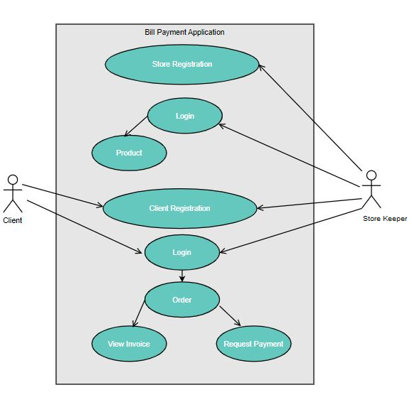

Brief Description | Client Registration
Basic Flow | This use case describes how a client register in to the system  - The client has to register himself or store can register into the system.  - After the successful registration, client will get a success message.  - The following information is required during registration.  - ID  - Name  - Mobile Number  - Email (Optional)  - Password  - Address (Optional)  - Balance (Optional)
Alternate Flow | - The system will validate the information provided. If any invalid data is found, the input form will be redirected with error message.
Validation | - ID is required unique number.  - Name should be string.  - Mobile number should be 10-digit number.  - The Email should be valid.  - Password should be maximum 10 characters.  - Address should be valid.  - Balance should be number.
Pre-Conditions | User should have network access and Browser with latest updates.
Post-Conditions | Success message should be shown.

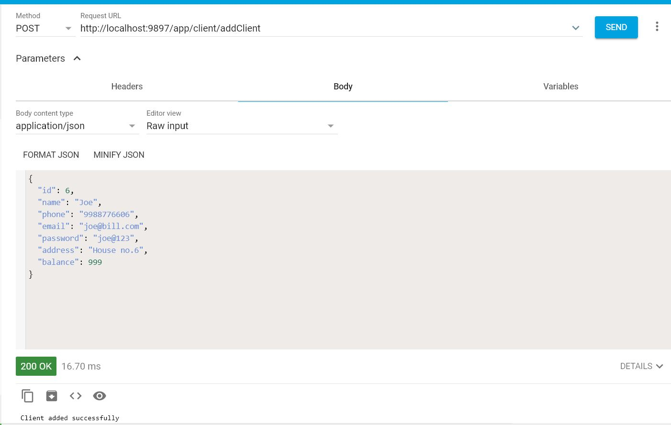

Brief Description | Store Registration
Basic Flow | This use case describes how a supplier register in to the system  - The store has to register himself into the system.  - After the successful registration, store will get a success message.  - The following information is required during registration.  - ID  - Name  - Mobile Number  - Email (Optional)  - Password  - Address (Optional)  - Balance (Optional)
Alternate Flow | - The system will validate the information provided. If any invalid data is found, the input form will be redirected with error message.
Validation | - ID is required unique number.  - Name should be string.  - Mobile number should be 10-digit number.  - The Email should be valid.  - Password should be maximum 10 characters.  - Address should be valid.  - Balance should be number.
Pre-Conditions | User should have network access and Browser with latest updates.
Post-Conditions | Success message should be shown.

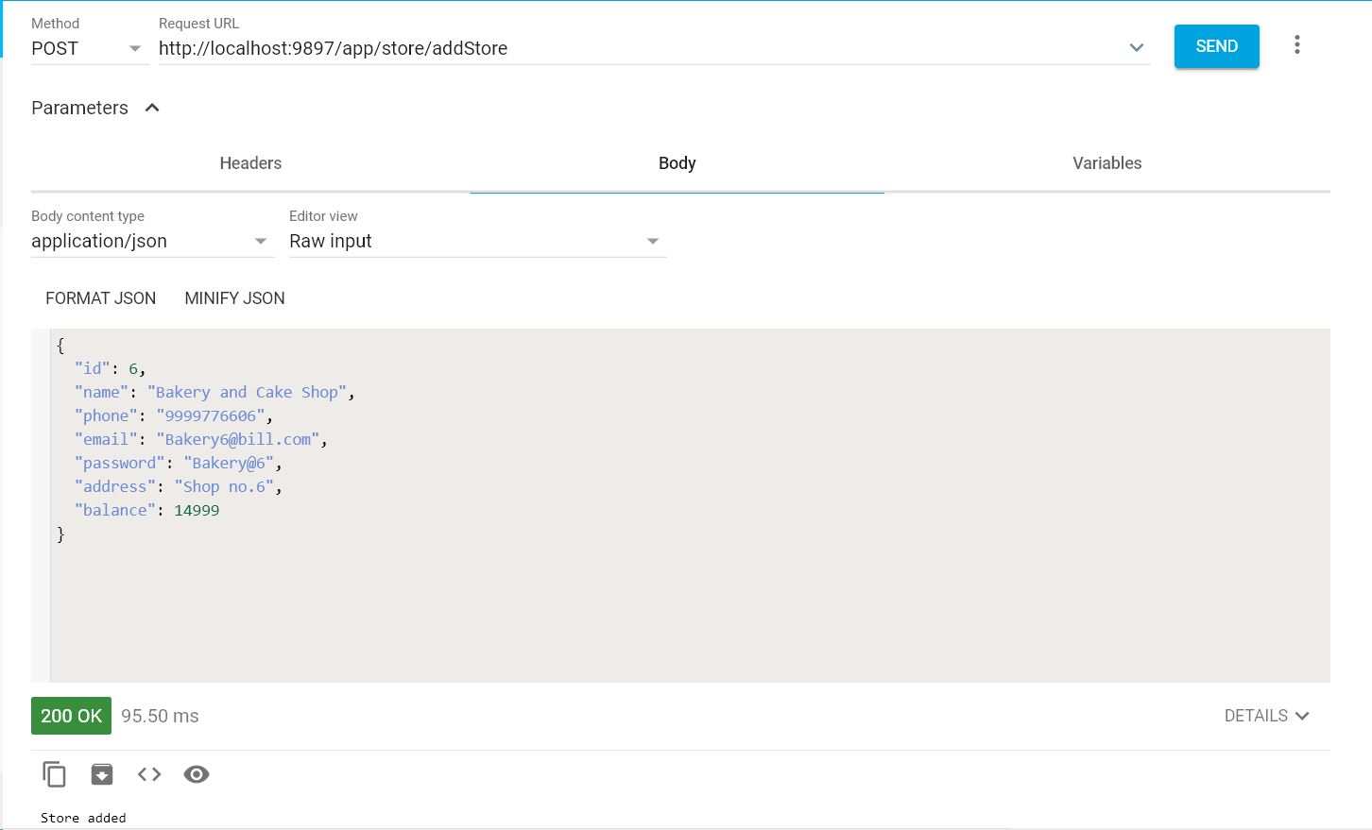
Brief Description | Login (Client/Store)
Basic Flow | This use case describes how a user log-in in to the system  - The client/store has to register himself into the system.  - After the successful login, user will be taken to the appropriate landing page.  - The following information is required to login.  - Mobile Number  - Password
Alternate Flow | - The system will validate the credentials provided. If credentials are invalid, login form will be redirected again with error message.
Validation | - Valid Mobile Number  - Valid password
Pre-Conditions | User should have network access and Browser with latest updates.
Post-Conditions | Landing page has to be displayed.

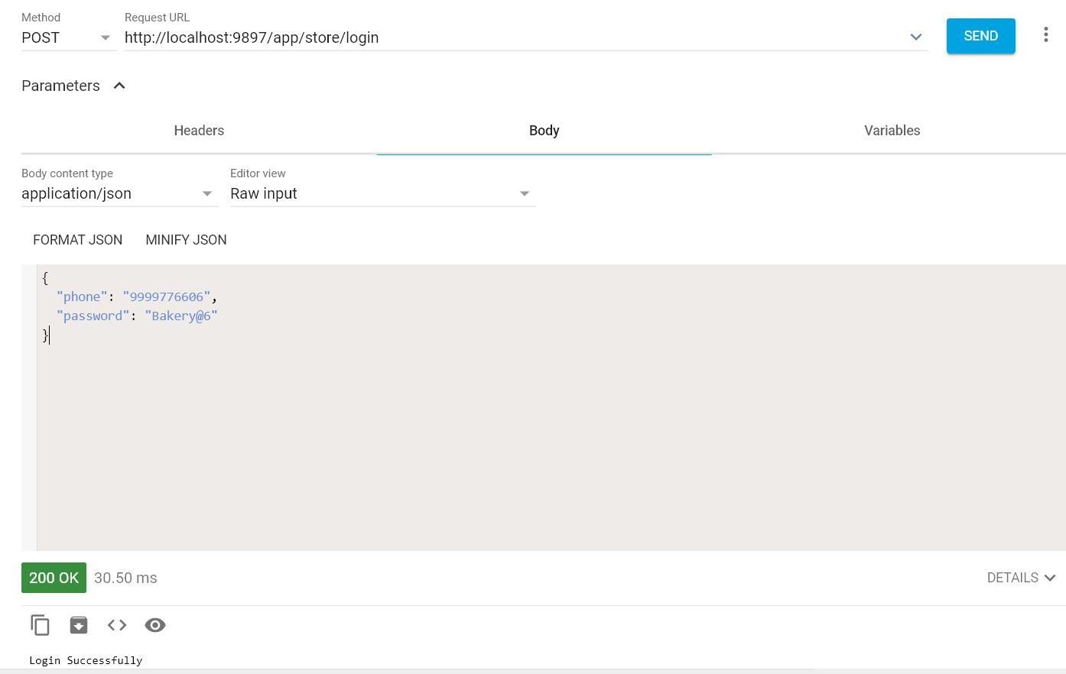

Brief Description | Add Product (Store)
Basic Flow | This use case describes how the store can add product.  - The store has to login into the system.  - The following information is required to add a product:  - ID  - Name  - Description  - Price  - Quantity  - Tax (%)  - Discount (%)
Alternate Flow | The system will validate the information provided. If any invalid data is found, the input form will be redirected with error message.
Validation | - ID is required unique number.  - Name should be string.  - Description should be string.  - Price should be number.  - Quantity should be number.  - Tax should be number.  - Discount should be number.
Pre-Conditions | User should have already logged into the system.
Post-Conditions | Success message should be shown.

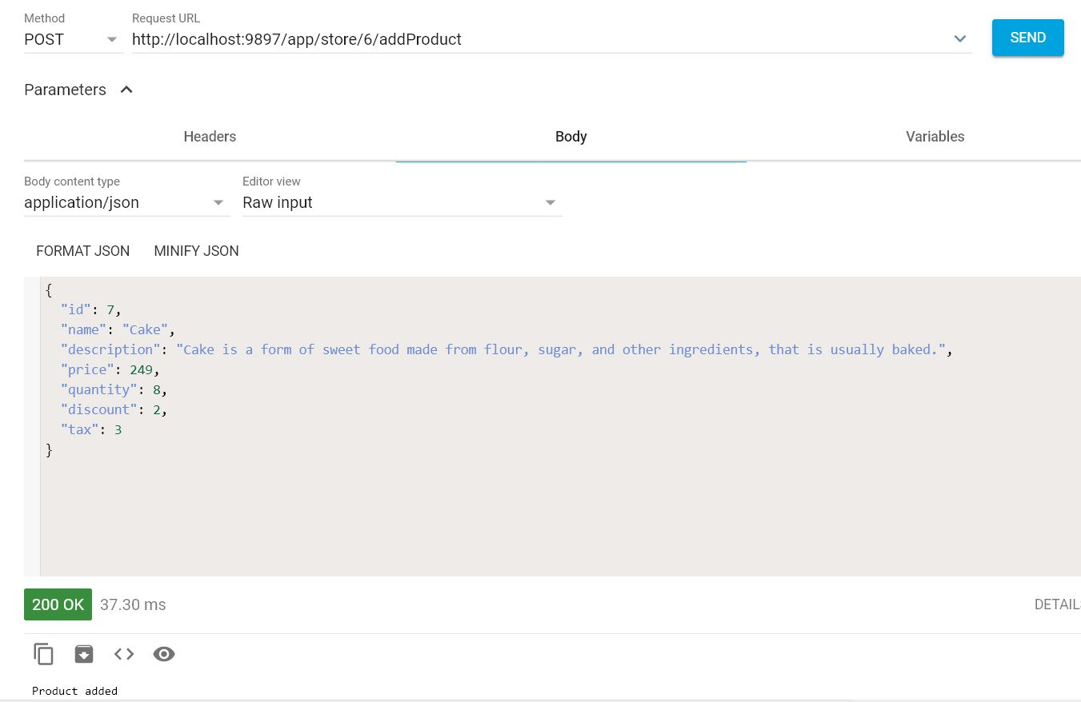

Brief Description | Create an Order
Basic Flow | This use case describes how the store can create order.  - The store has to login into the system.  - The following information is required to create an order:  - Order ID  - Client ID  - Allows store to add product into cart.  - Allows store to accept payment.  - Total amount will be auto calculated by system.
Alternate Flow | If payment process will fail then failure message should be shown.
Validation | Order ID is required unique number.
Pre-Conditions | User should have already logged into the system.
Post-Conditions | Success message should be shown.

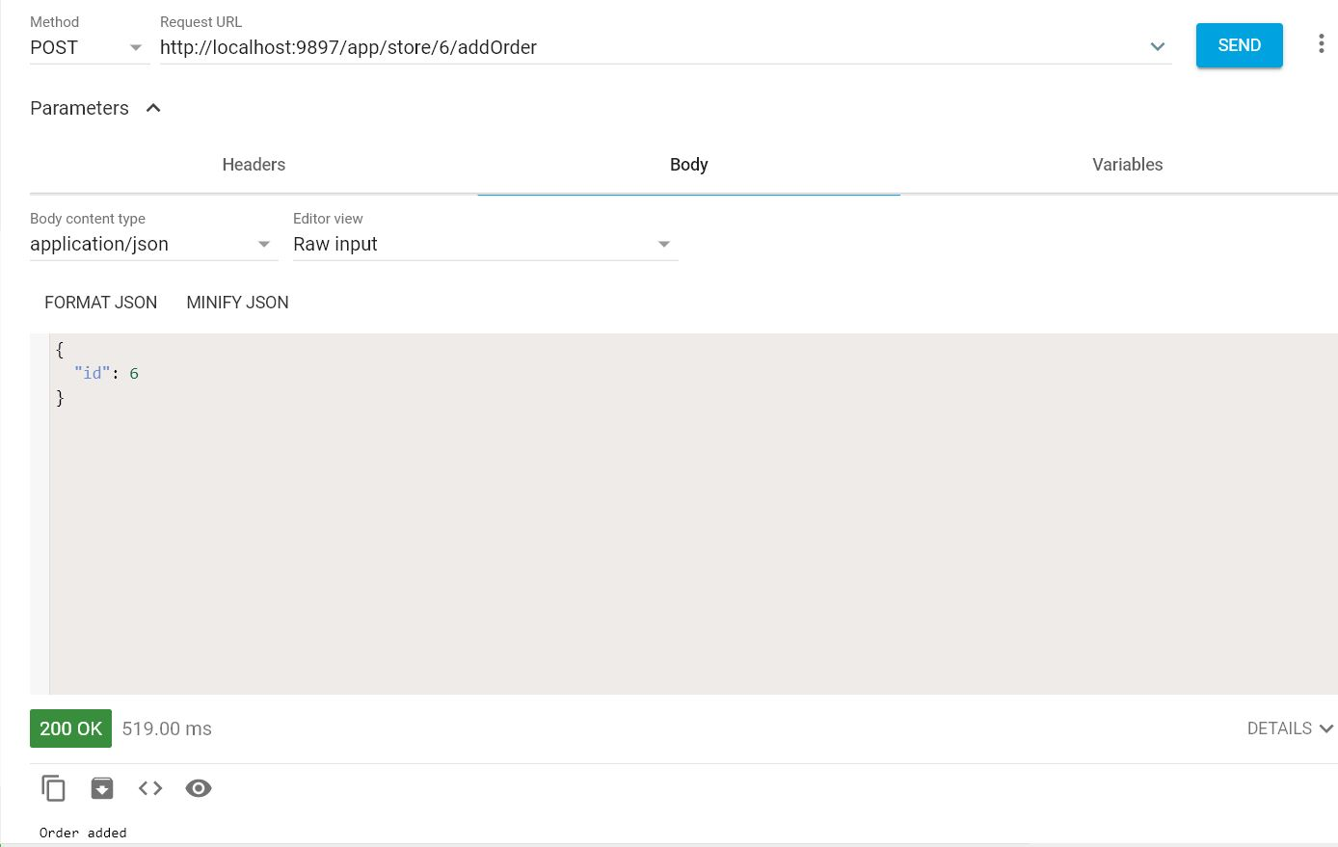

Brief Description | Order-Product (Cart) Module
Basic Flow | This use case describes cart.  - The cart contains the details of the order.  - Allows store to create cart for client based on following attributes:  - Order ID  - Allows store to add product based on following attributes:  - Total amount will be auto calculated by system which will reflect into order module.
  - Product ID
  - Quantity
Alternate Flow | If product will not available out of stock message should be shown.
Validation | Not Applicable.
Pre-Conditions | User should have already logged into the system.
Post-Conditions | Success message should be shown.

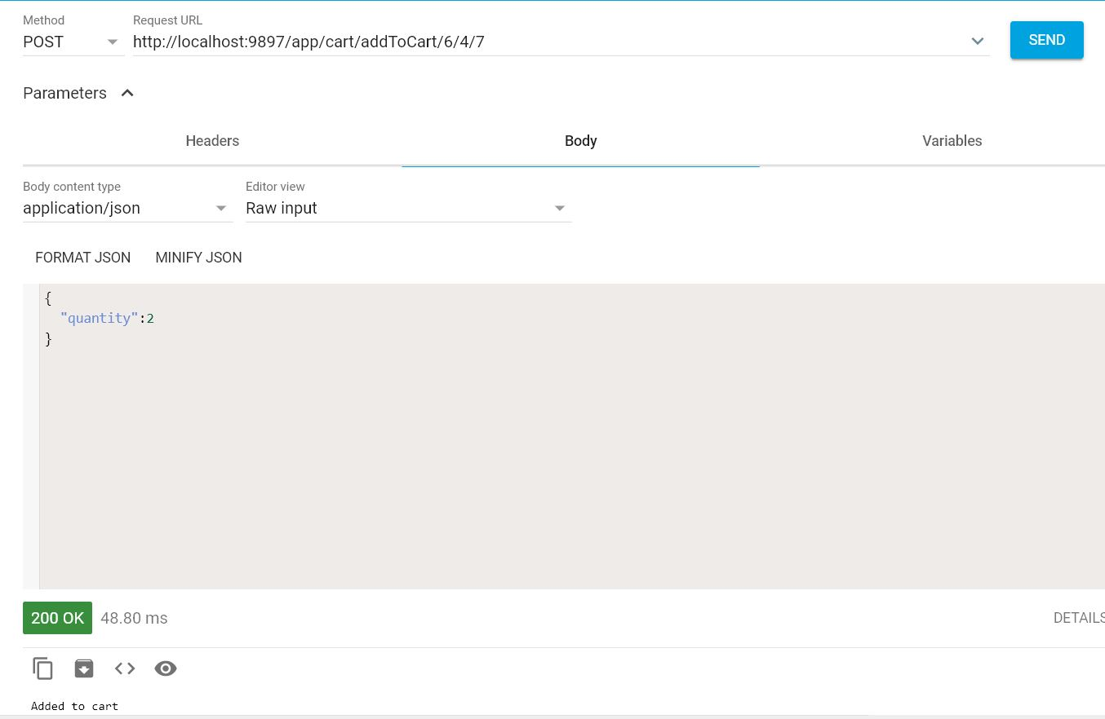

Brief Description | View Invoice (Client/Store)
Basic Flow | This use case describes how a client/store can view the status of invoice.  - The store has to login into the system.  - The following information has to be displayed.  - Invoice number  - Invoice Date  - Invoice amount  - Invoice Status  - Payment Mode  - Transaction ID
Alternate Flow | Not Applicable
Validation | Not Applicable
Pre-Conditions | User should have already logged into the system.
Post-Conditions | Not Applicable

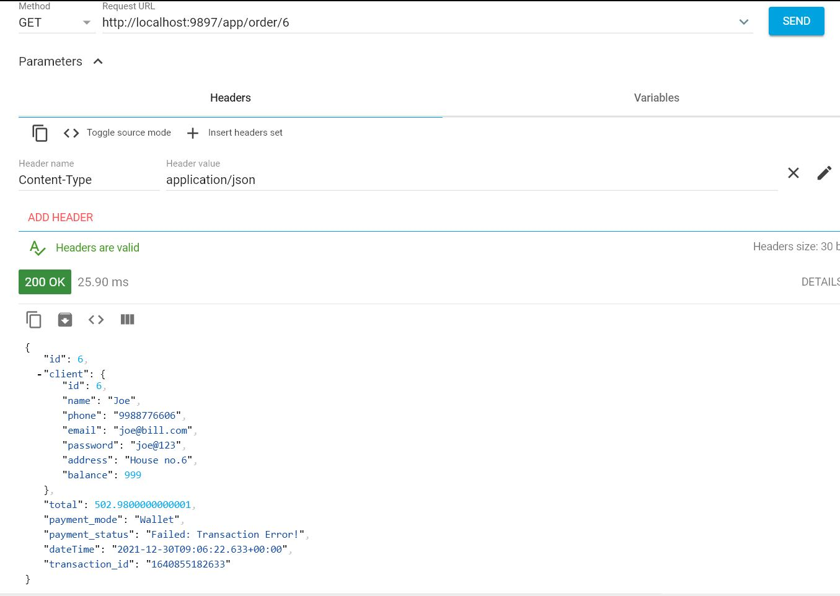

Brief Description | Request Payment (Supplier)
Basic Flow | This use case describes how a store can request for payment, which are applicable for them.  - The store has to login into the system.  - Allows store to search based on following attributes.  - Invoice number  - Display the invoice matches the given criteria.  - Request for payment.  - Status of the invoice has to be updated.
Alternate Flow | Not Applicable
Validation | Not Applicable
Pre-Conditions | User should have already logged into the system.
Post-Conditions | Success message should be shown.

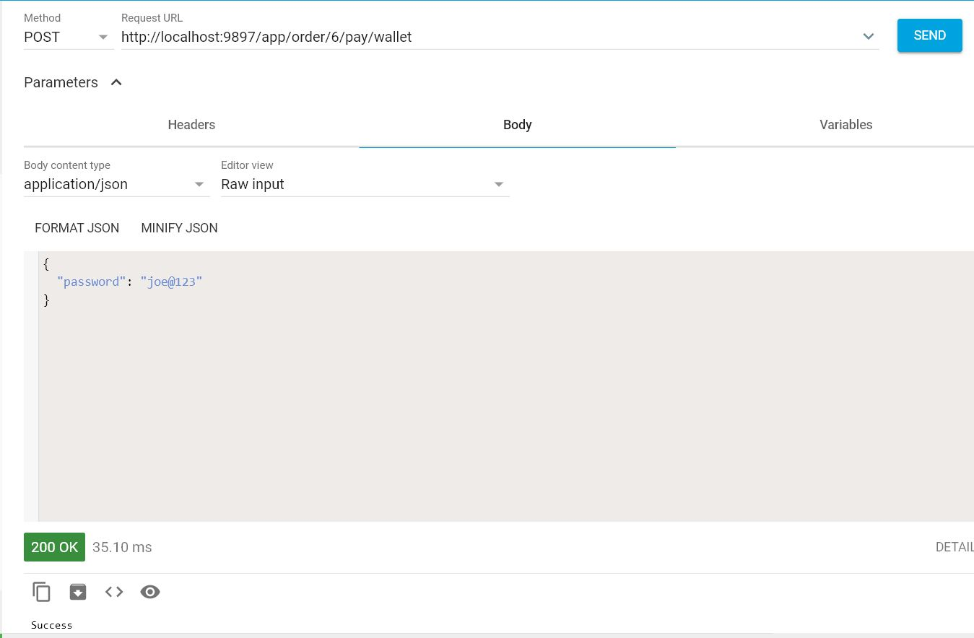

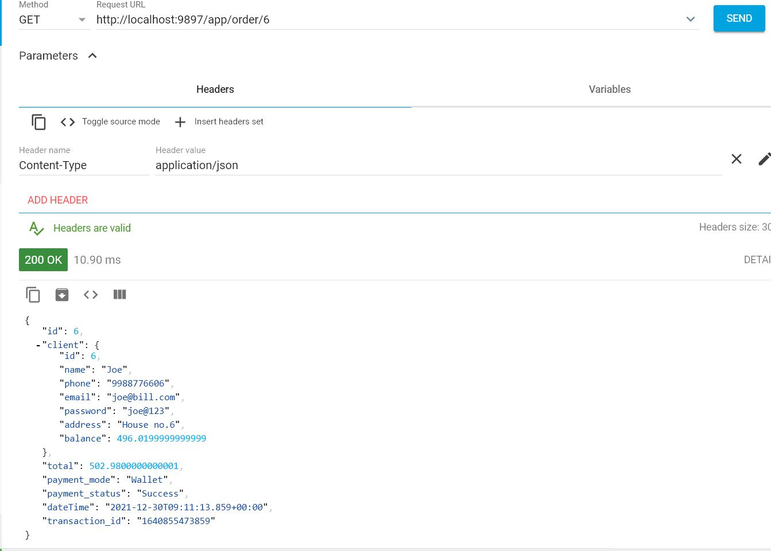
Architecture Diagram

Layer
Logical View
Technology/ Framework

UI Components
Presentation Layer
HTML/ CSS/ JavaScript

Web-Server Classes
Java 1.8/ Spring Boot
Application/ Business Layer
REST Controllers

Entity/ Model Classes

Data Access Layer
Repository classes
Crud Repository

Oracle 11g Database

Presentation Layer:
This layer consists of all UI components.
- Resources: All HTML/CSS, which are required for the page design.

Application Layer:
This layer comprises of all server and business classes.
- REST Controllers to process the HTTP requests.
- Model classes are used the define the functions of the entities present in the system.
Data Layer:
Data layer is implemented through Crud Repository. It will contain the repository classes, which provides interface to the table.

Class Diagram

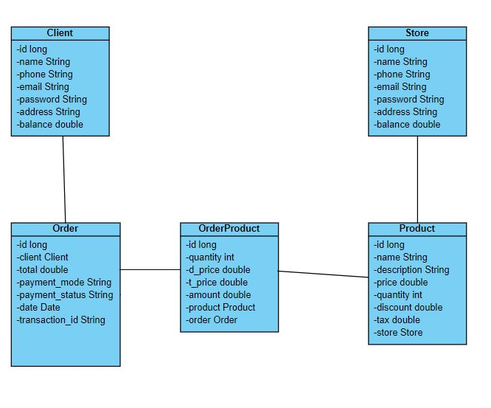

Sequence diagram

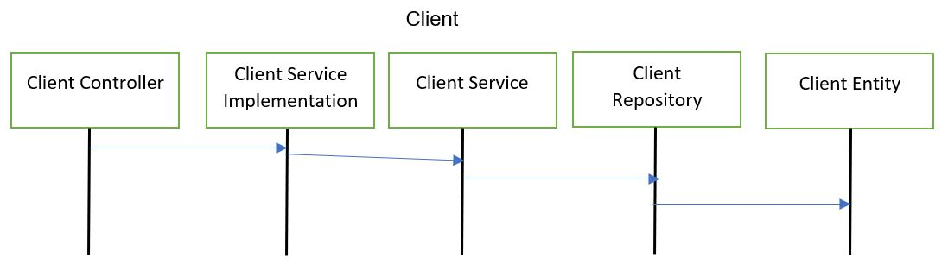
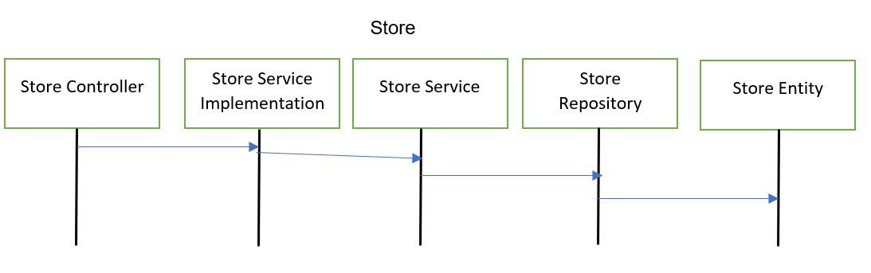
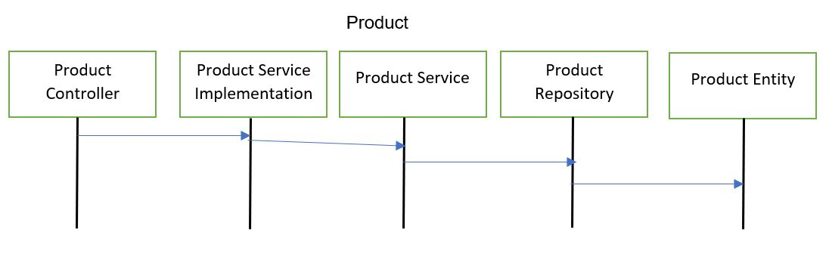

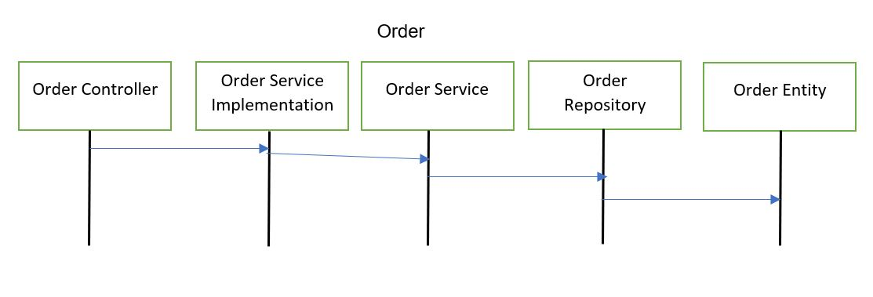
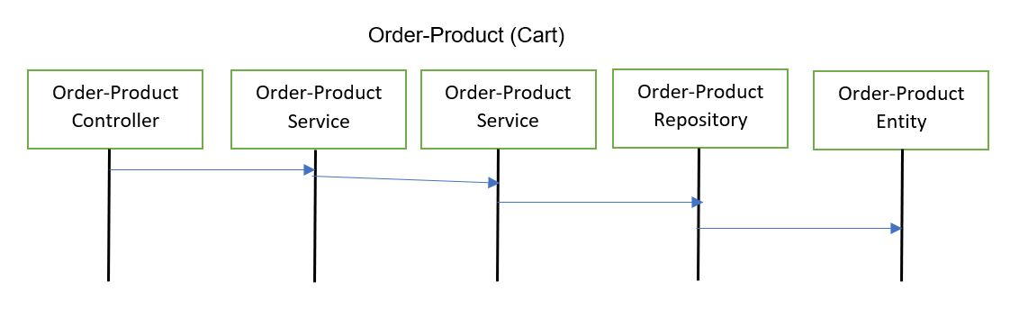

References
Java Complete Reference: Herbert Schildt

